Lecture#1 Introduction to Flutter
Objectives
- Introduction
- Features of Flutter
- Advantages of Flutter
- Disadvantages of Flutter
- Installation

What is Flutter?
Flutter is an open-source framework to create high quality, high performance mobile applications across mobile operating systems - Android and iOS. It provides a simple, powerful, efficient and easy to understand SDK to write mobile application in Google’s own language, Dart. This tutorial walks through the basics of Flutter framework, installation of Flutter SDK, setting up Android Studio to develop Flutter based application, architecture of Flutter framework and developing all type of mobile applications using Flutter framework.
In general, developing a mobile application is a complex and challenging task. There are many frameworks available to develop a mobile application. Android provides a native framework based on Java language and iOS provides a native framework based on Objective-C / Swift language.
However, to develop an application supporting both the OSs, we need to code in two different languages using two different frameworks. To help overcome this complexity, there exists mobile frameworks supporting both OS. These frameworks range from simple HTML based hybrid mobile application framework (which uses HTML for User Interface and JavaScript for application logic) to complex language specific framework (which do the heavy lifting of converting code to native code). Irrespective of their simplicity or complexity, these frameworks always have many disadvantages, one of the main drawbacks being their slow performance.
In this scenario, Flutter – a simple and high-performance framework based on Dart language, provides high performance by rendering the UI directly in the operating system’s canvas rather than through native framework.
Flutter also offers many ready to use widgets (UI) to create a modern application. These widgets are optimized for mobile environment and designing the application using widgets is as simple as designing HTML.
To be specific, Flutter application is itself a widget. Flutter widgets also supports animations and gestures. The application logic is based on reactive programming. Widget may optionally have a state. By changing the state of the widget, Flutter will automatically (reactive programming) compare the widget’s state (old and new) and render the widget with only the necessary changes instead of re-rendering the whole widget.
Features of Futter
Flutter framework offers the following features to developers −
- Modern and reactive framework.
- Uses Dart programming language and it is very easy to learn.
- Fast development.
- Beautiful and fluid user interfaces.
- Huge widget catalog.
- Runs same UI for multiple platforms.
- High performance application.

Advantages of Flutter:
Flutter framework offers the following features to developers −
- Modern and reactive framework.
- Uses Dart programming language and it is very easy to learn.
- Fast development.
- Beautiful and fluid user interfaces.
- Huge widget catalog.
- Runs same UI for multiple platforms.
- High performance application.

Disadvantages of Flutter
Despite its many advantages, flutter has the following drawbacks in it −
- Since it is coded in Dart language, a developer needs to learn new language (though it is easy to learn).
- Modern framework tries to separate logic and UI as much as possible but, in Flutter, user interface and logic is intermixed. We can overcome this using smart coding and using high level module to separate user interface and logic.
- Flutter is yet another framework to create mobile application. Developers are having a hard time in choosing the right development tools in hugely populated segment.
Installation:
Follow the following step to install flutter
Step 1 Getting Started with Flutter:
Go to https://flutter.dev/
Click on get started shown in figure given below.
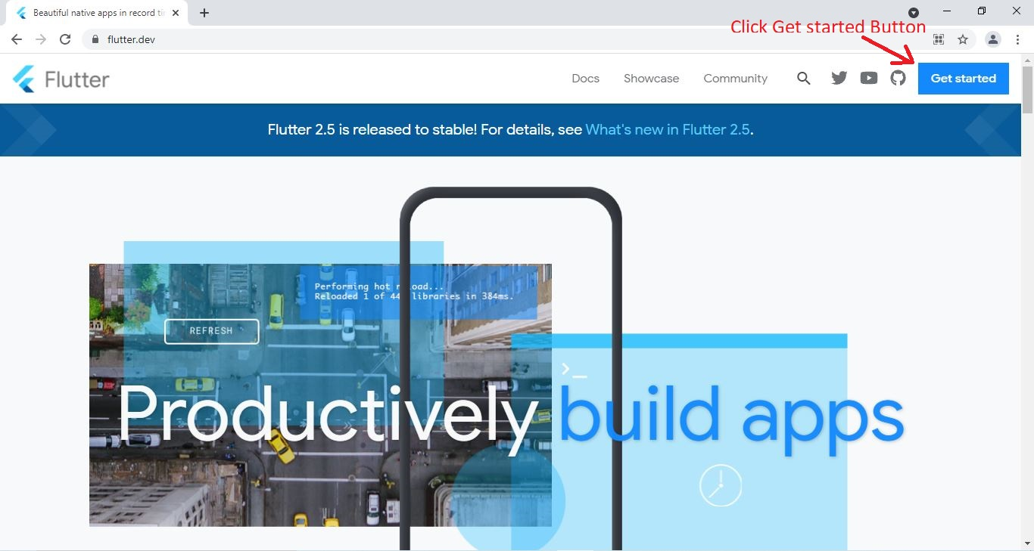
Fig 1 Flutter.dev Page
Step 2 Select your OS:
After clicking Get Started button a following web page will be shown. Click on your OS.
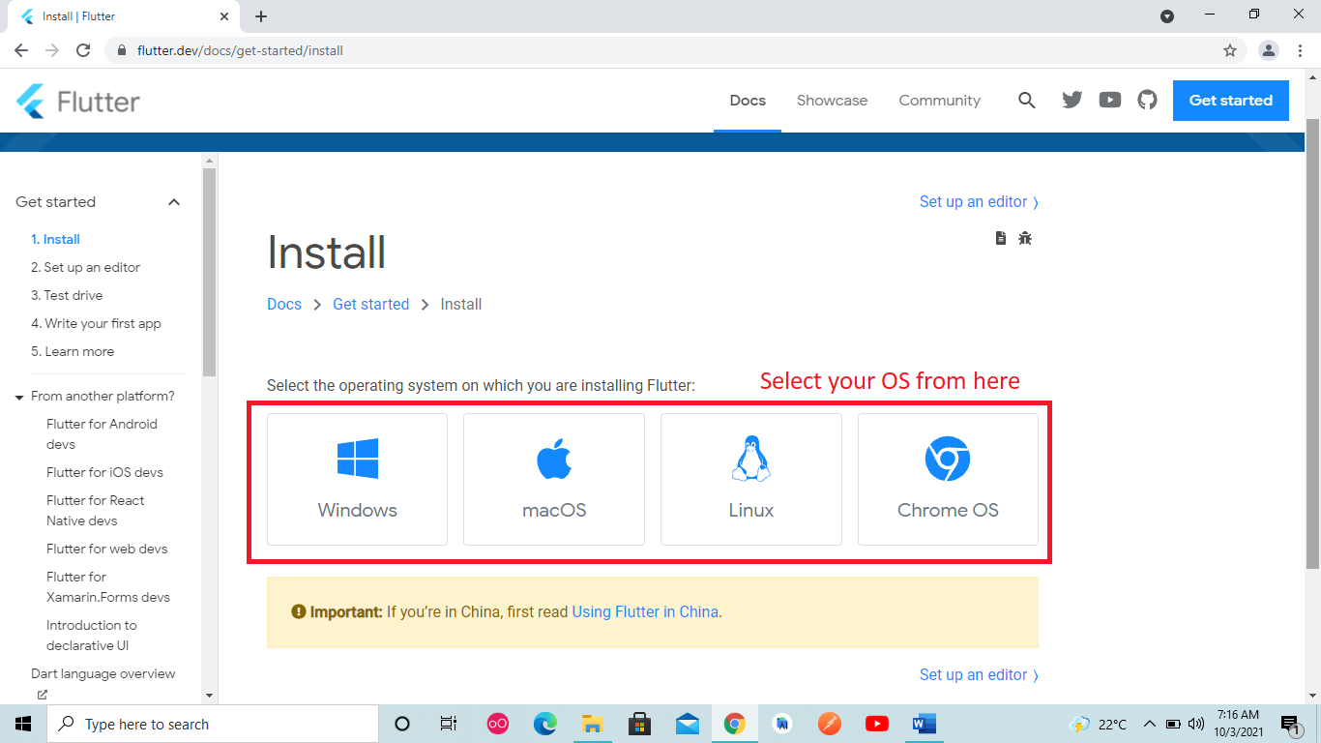
Fig 2 Select your OS
Step 3 Downloading Flutter SDK:
System requirements
To install and run Flutter, your development environment must meet these minimum requirements:
- Operating Systems: Windows 7 SP1 or later (64-bit), x86-64 based.
- Disk Space: 1.64 GB (does not include disk space for IDE/tools).
- Tools: Flutter depends on these tools being available in your environment.
  - Windows PowerShell 5.0 or newer (this is pre-installed with Windows 10)
  - Git for Windows 2.x, with the Use Git from the Windows Command Prompt option.
If Git for Windows is already installed, make sure you can run git commands from the command prompt or PowerShell.
Download Flutter SDK
After selection your OS as shown in figure 2 install flutter SDK shown below.
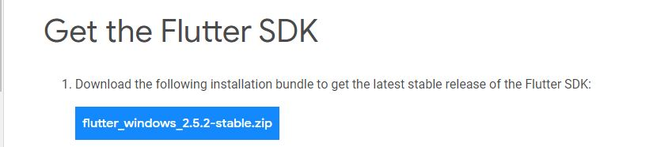
Fig 3 Flutter SDK
Flutter SDK will be according to your OS. Extract the zip file and place the contained flutter in the desired installation location for the Flutter SDK (for example, C:\Users\<your-user-name>\Documents).
Warning: Do not install Flutter in a directory like C:\Program Files\ that requires elevated privileges.
Step 4 Updating Environment Variables:
If you wish to run Flutter commands in the regular Windows console, take these steps to add Flutter to the PATH environment variable:
- From the Start search bar, enter ‘env’ and select Edit environment variables for your account.
- Under User variables check if there is an entry called Path:
  - If the entry exists, append the full path to flutter\bin using ; as a separator from existing values.
  - If the entry doesn’t exist, create a new user variable named Path with the full path to flutter\bin as its value.
You have to close and reopen any existing console windows for these changes to take effect.
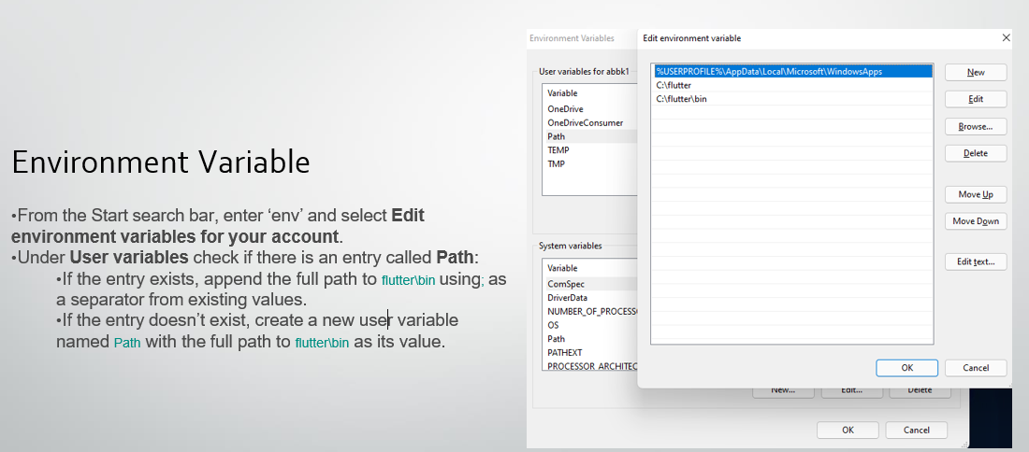
Fig 4 Update Environment Variable

Flutter Commands
As of Flutter’s 1.19.0 dev release, the Flutter SDK contains the dart command alongside the flutter command so that you can more easily run Dart command-line programs. Downloading the Flutter SDK also downloads the compatible version of Dart, but if you’ve downloaded the Dart SDK separately, make sure that the Flutter version of dart is first in your path, as the two versions might not be compatible. The following command tells you whether the flutter and dart commands originate from the same bin directory and are therefore compatible.
where flutter dart
C:\path-to-flutter-sdk\bin\flutter
C:\path-to-flutter-sdk\bin\flutter.bat
C:\path-to-dart-sdk\bin\dart.exe :: this should go after `C:\path-to-flutter-sdk\bin\` commands
C:\path-to-flutter-sdk\bin\dart
C:\path-to-flutter-sdk\bin\dart.bat

As shown above, the command dart from the Flutter SDK doesn’t come first. Update your path to use commands from C:\path-to-flutter-sdk\bin\ before commands from C:\path-to-dart-sdk\bin\ (in this case). After restarting your shell for the change to take effect, running the where command again should show that the flutter and dart commands from the same directory now come first.
where flutter dart
C:\dev\src\flutter\bin\flutter
C:\dev\src\flutter\bin\flutter.bat
C:\dev\src\flutter\bin\dart
C:\dev\src\flutter\bin\dart.bat
C:\dev\src\dart-sdk\bin\dart.exe
However, if you are using PowerShell, in it where is an alias of Where-Object command, so you need to use where.exe instead.
where.exe flutter dart

Run flutter doctor
From a console window that has the Flutter directory in the path (see above), run the following command to see if there are any platform dependencies you need to complete the setup:
C:\src\flutter>flutter doctor
This command checks your environment and displays a report of the status of your Flutter installation. Check the output carefully for other software you might need to install or further tasks to perform (shown in bold text).
For example:
[-] Android toolchain - develop for Android devices
• Android SDK at D:\Android\sdk
✗ Android SDK is missing command line tools; download from https://goo.gl/XxQghQ
• Try re-installing or updating your Android SDK,
visit https://flutter.dev/setup/#android-setup for detailed instructions.
The following sections describe how to perform these tasks and finish the setup process. Once you have installed any missing dependencies, you can run the flutter doctor command again to verify that you’ve set everything up correctly.
Note: If flutter doctor returns that either the Flutter plugin or Dart plugin of Android Studio are not installed, move on to Set up an editor to resolve this issue.

Android setup

Install Android Studio
- Download and install https://developer.android.com/studio
- Start Android Studio, and go through the ‘Android Studio Setup Wizard’. This installs the latest Android SDK, Android SDK Command-line Tools, and Android SDK Build-Tools, which are required by Flutter when developing for Android.
- Run flutter doctor to confirm that Flutter has located your installation of Android Studio. If Flutter cannot locate it, run flutter config --android-studio-dir <directory> to set the directory that Android Studio is installed to.
Agree to Android Licenses
Before you can use Flutter, you must agree to the licenses of the Android SDK platform. This step should be done after you have installed the tools listed above.
- Make sure that you have a version of Java 8 installed and that your JAVA_HOME environment variable is set to the JDK’s folder.
Android Studio versions 2.2 and higher come with a JDK, so this should already be done.
- Open an elevated console window and run the following command to begin signing licenses.
$ flutter doctor --android-licenses
- Review the terms of each license carefully before agreeing to them.
- Once you are done agreeing with licenses, run flutter doctor again to confirm that you are ready to use Flutter.

Android Virtual Device
To setup the android virtual device download Genymotion
Go to -> https://www.genymotion.com/

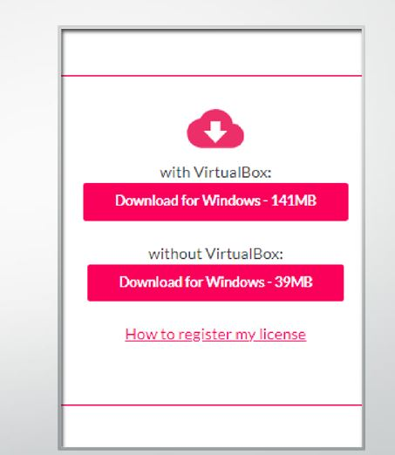
Fig 5 Genymotion click on download for windows
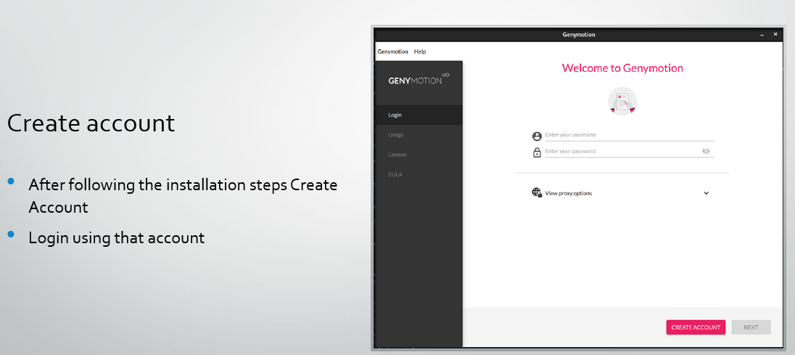
Fig 6 Create Account
Create Virtual Device:
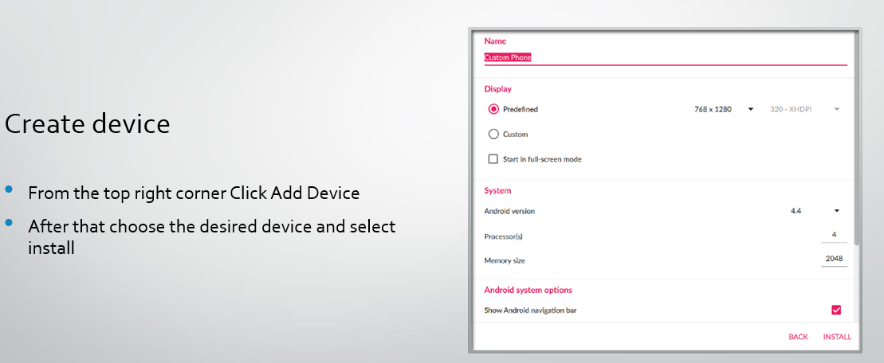
Fig 7 Creating Virtual Device
Start Device:
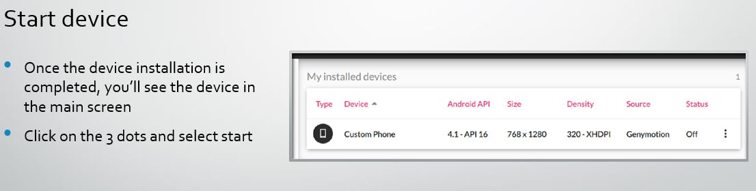
Fig 8 Start Device
Install VS Code from https://code.visualstudio.com/download
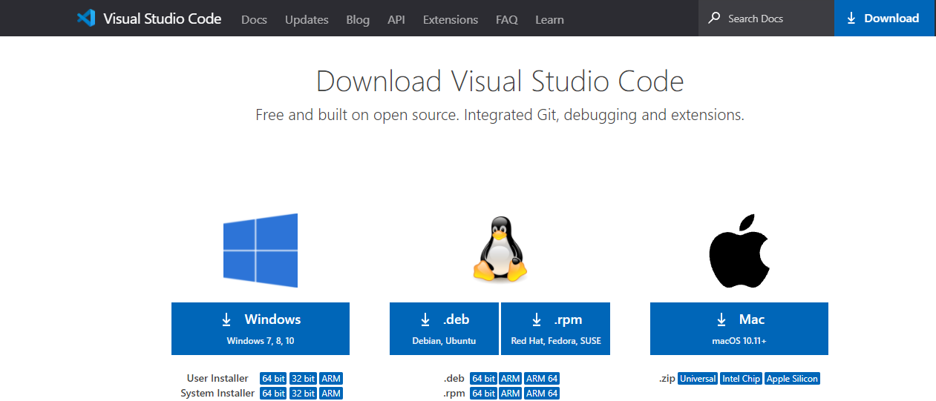
Fig 9 Start Download and Install
Once VS Code is installed add flutter extension as shown in figure given below.
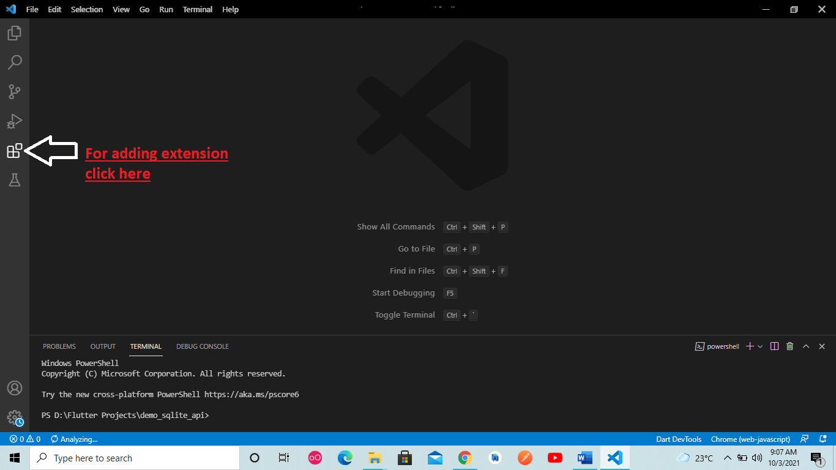Fig 9 Adding extension
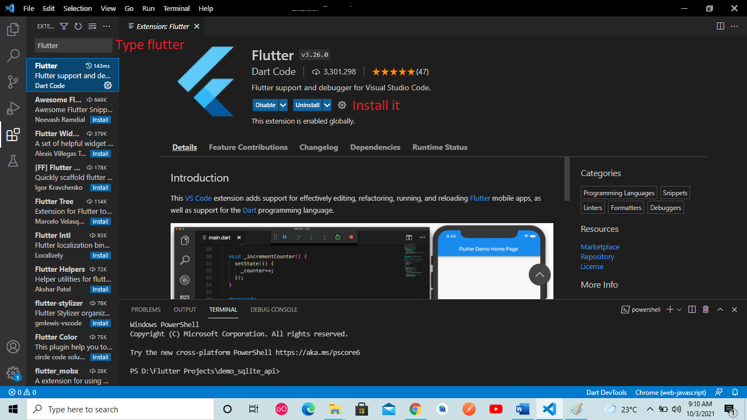
Fig 10 Type Flutter and install it

Lecture#2 Dart Basics
Objectives
- Data Types
  - int
  - bool
  - double
  - num
  - var
  - dynamic
  - String
  - List
  - Set
  - Map

Basic type understanding
Void main( ){
// declaring a data type
int num1= 5, num2= 6;
int sum=num1+num2;
String result_display = "Sum of "+num1+"&"+num2+" = "+sum;
// above statement has error num1 and num2 must be converted to string for concatenation
// above statement should be written as follow
String result = "Sum of "+num1.toString( )+"&"+num2.toString( ) +"="+ sum. toString( );
//String interpolation can be used as well
// for String interpolation with variable $ symbol is used
String answer = "Sum of $num1 & $num2 = $sum ";
int y = num2 / num1 ; // error as / operator returns double value
// to resolve above issue change data type to double
double y = num2 / num1;
num k=90; // can store both integer and decimal values
var v1=56; // data type of v1 will be integer and cannot be changed
dynamic d1 = 56; // data type of d1 is 56 and can be changed
d1 = " data type is changed to string " ; // data type of d1 is changed to integer
// note that dynamic changes to the data type of data assigned to it
}

List<E> class
An indexable collection of objects with a length.
Subclasses of this class implement different kinds of lists. The most common kinds of lists are:
- Fixed-length list
An error occurs when attempting to use operations that can change the length of the list.
- Growable list
Full implementation of the API defined in this class.
The default growable list, as created by [], keeps an internal buffer, and grows that buffer when necessary. This guarantees that a sequence of add operations will each execute in amortized constant time. Setting the length directly may take time proportional to the new length, and may change the internal capacity so that a following add operation will need to immediately increase the buffer capacity. Other list implementations may have different performance behavior.
Example of fixed-length list:
final fixedLengthList = List<int>.filled(5, 0); // Creates fixed-length list.
print(fixedLengthList); // [0, 0, 0, 0, 0]
fixedLengthList[0] = 87;
fixedLengthList.setAll(1, [1, 2, 3]);
print(fixedLengthList); // [87, 1, 2, 3, 0]
// Fixed length list length can't be changed or increased
fixedLengthList.length = 0; // Throws
fixedLengthList.add(499); // Throws
Example of growable list:
final growableList = <String>['A', 'B']; // Creates growable list.
To add data to the growable list, use operator[]=, add or addAll.
growableList[0] = 'G';
print(growableList); // [G, B]
growableList.add('X');
growableList.addAll({'C', 'B'});
print(growableList); // [G, B, X, C, B]
To check whether, and where, the element is in the list, use indexOf or lastIndexOf.
final indexA = growableList.indexOf('A'); // -1 (not in the list)
final firstIndexB = growableList.indexOf('B'); // 1
final lastIndexB = growableList.lastIndexOf('B'); // 4
To remove an element from the growable list, use remove, removeAt, removeLast, removeRange or removeWhere.
growableList.remove('C');
growableList.removeLast();
print(growableList); // [G, B, X]
To insert an element at position in the list, use insert or insertAll.
growableList.insert(1, 'New');
print(growableList); // [G, New, B, X]
To replace a range of elements in the list, use fillRange, replaceRange or setRange.
growableList.replaceRange(0, 2, ['AB', 'A']);
print(growableList); // [AB, A, B, X]
growableList.fillRange(2, 4, 'F');
print(growableList); // [AB, A, F, F]
To sort the elements of the list, use sort.
growableList.sort((a, b) => a.compareTo(b));
print(growableList); // [A, AB, F, F]
To shuffle the elements of this list randomly, use shuffle.
growableList.shuffle();
print(growableList); // e.g. [AB, F, A, F]
To find the first element satisfying some predicate, or give a default value if none do, use firstWhere.
bool isVowel(String char) => char.length == 1 && "AEIOU".contains(char);
final firstVowel = growableList.firstWhere(isVowel, orElse: () => ''); // ''
Sets
Sets are similar to lists, with two distinctions. While a List is ordered, a set is unordered. Also, the objects in a Set are unique. And that is a guarantee.
For example, if you have a Set of int objects, and you try to add 1 to the set twice, the second attempt simply won't work. It won't throw an error or fail in anyway. Instead, Dart will just realize that the 1 already exists in the set, and it'll move on.In order to create a set, you use the set constructor function or a Set literal.
// with constructor
Set<int> specialNumbers = Set();

// set literal
Set<int> literalSpecialNumbers = {1, 4, 6};
Sets and maps have the the same syntax for their literal implementation. When you define a set literal, you must annotate the type of the variable. Otherwise, it will default to a `Map`.
Other than that, interacting with a set is similar to interacting with a List.
Set<int> specialNumbers = Set();
specialNumbers.add(3);
print(specialNumbers);
specialNumbers.add(6);
print(specialNumbers);
// won't get added!
specialNumbers.add(6);
print(specialNumbers);
// output
// => [3]
// => [3, 6]
// => [3, 6]

